10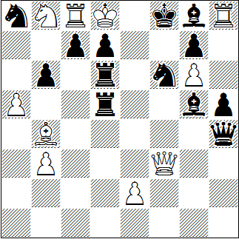
S#2 10+13
11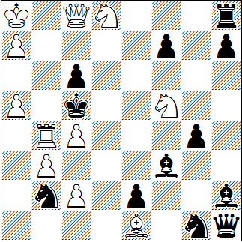
S#3 11+12
12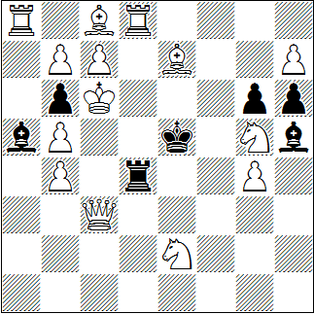
S#4 14+7

Hartmut Laue, Polnischer Schachverband 2013, 1.-3. Pr.
1. | Ld2? | Tf5!
1. | Le1? | Lf4!
1. | Dd3? | Tc5!
1. | De4! | dr. | 2. | De8+ | @ | Sxe8 #
1. | ... | Te5 | 2. | Sxd7+ | @ | Sxd7 #
1. | ... | Sf~+ | 2. | De7+ | @ | Lxe7 #
1. | ... | Dxe4 | 2. | Sxd7+ | @ | Sxd7 #

Andrej Lobusov, Themes 64 1975, 3. Pr.
1. | Tb8! | dr. | 2. | Dxc6+ | Lxc6+ | 3. | Sb7+ | @ | Lxb7 #
1. | … | Lc7 | 2. | Se6+ | fxe6 | 3. | Tb5+ | @ | cxb5 #
1. | … | Sxc4 | 2. | Tb5+ | Kxb5 | 3. | Dxc6+ | @ | Lxc6 #
1. | … | Txd8 | 2. | b4+ | Kxc4 | 3. | Dxc6+ | @ | Lxc6 #

Vukota Nikoletic, idee & form 2001
1. | Te8! | Lxb4 | 2. | Sf7+ | Ke4 | 3. | Lf6+ | Le7 | 4. | Sd6+ | @
1. | ... | Lxg4 | 2. | De3+ | Te4 | 3. | Sf3+ | Lxf3 | 4. | Dd4+ | @
1. | ... | hxg5 | 2. | h8L+ | Ke4 | 3. | Lf5+ | gxf5 | 4. | Ld8+ | @

@ | 1 | 2 | 3 | 4
10 | 1 | 2,5 | 4 | 5
11 | 1 | 2,5 | 4 | 5
12 | 1,5 | 3 | 5

