16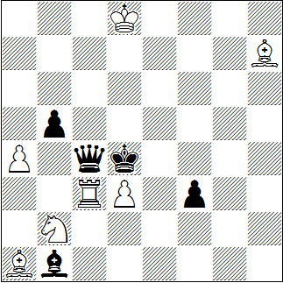
H#2 4 sol 7+5
17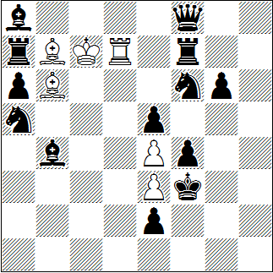
H#3 3 sol 6+13
18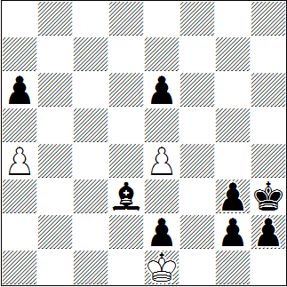
H#5 2 sol 3+8

Christopher Jones, Original
1. | Ke3 | Tc2 | 2. | Df4 | Sd1 # | @
1. | bxa4 | Sxa4 | 2. | Lxd3 | Txd3 # | @
1. | Dxc3 | Le4 | 2. | Dc5 | Sc4 # | @
1. | Dxd3 | Tc5 | 2. | De3 | Sd3 # | @

Arnold Beine, Original für DM 2015 (nach John Niemann)
1. | Sxe4 | Lxa5 | 2. | Kxe3 | Lxb4 | 3. | Sf2 | Ld2 # | @
1. | Sc6 | Lxa7 | 2. | Kxe4 | Lxa6 | 3. | f3 | Ld3 # | @
1. | Le7 | Td5 | 2. | Kxe4 | Td4+ | 3. | Kxe3 | Td6 # | @

Oto Mihalco, Jozef Holubec, Cumakov JT 1970, 3. HM
1. | g1L | a5 | 2. | Lb6 | axb6 | 3. | Kg2 | b7
4. | Kg1 | b8D | 5. | h1T | Dxg3 # | @
1. | Lb5 | axb5 | 2. | g1S | bxa6 | 3. | h1D | a7
4. | Dxe4 | a8D | 5. | Dg4 | Dh1 # | @

@ | 1 | 2 | 3 | 4
16 | 1 | 2,5 | 4 | 5
17 | 1,5 | 3 | 5
18 | 2,5 | 5

